St. Francis Institute of Technology, Mumbai-400 103

**Department Of Information Technology**

A.Y. 2024-2025

Class: TE-ITA/B, Semester: V

Subject: **DevOps Lab**

**Experiment – 8: To setup and run Selenium tests in Jenkins using Maven.** 

**1. Aim:** To setup and run Selenium tests in Jenkins using Maven

**2. Objectives:** Aim of this experiment is that, the students will learn:

**●** Selenium and how to automate your test cases for testing web elements

**●** Introduction to X-Path, TestNG and integrate Selenium with Jenkins and Maven. **3. Outcomes:** After study of this experiment, the students will learn following: ● Introduction to Selenium

● Installing Selenium

● Creating Test Cases in Selenium WebDriver

● Run Selenium Tests in Jenkins Using Maven

**4. Prerequisite:** Knowledge of Software Engineering concept of testing and test cases. **5. Requirements:** Jenkins, JDK, Eclipse IDE, Firefox browser, Personal Computer, Windows operating system, Internet Connection, Microsoft Word.

**6. Pre-Experiment Exercise:**

**Brief Theory:** Refer shared material

**7. Laboratory Exercise**

**A. Procedure:**

**a. Answer the following:**

● Explain Selenium suite?

● What are the limitations of Selenium IDE?

**b**. **Execute following (Refer the shared material) and attach screenshots:** ● Create and run a test case on Chrome/Firefox browser with selenium IDE addon

● Create a Maven Project in Jenkins and run selenium tests using selenium Grid

**8. Post-Experiments Exercise**

**A. Extended Theory:**

Nil

**B. Questions:**

● What are Locators? Explain its types.

● What is the benefit of using Selenium Grid with Jenkins?

**C. Conclusion:**

● Write what was performed in the experiment.

● Write the significance of the topic studied in the experiment.

**D. References:**

https://jenkins.io/doc/

https://www.slideshare.net/abediaz/introduction-to-jenkins

https://q-automations.com/2019/09/26/selenium-grid-with-jenkins/

F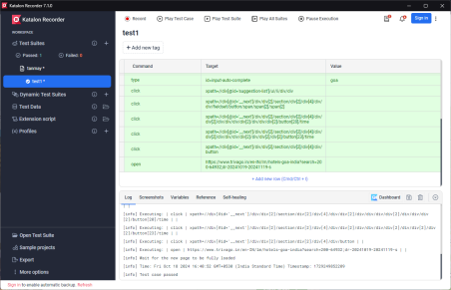

Getting screenshot by adding screenshot command at end

